
Introduction to DOSBox
Lab 10

Computer Organization and Assembly Language

Student Name | Muhammad Hassan Khalid
Registration # | 21L-5692
Instructor | Hazoor Ahmad
Class | CS3
Section | A1, A2, D1, D2
Semester | Fall 2022

Fast School of Computing
FAST-NU, Lahore, Pakistan

Activity 1

Assembly Language Code
[org 0x0100]
jmp start
tickcount: dw 0
; subroutine to print a number at top left of screen
; takes the number to be printed as its parameter
clrscr: push es
push ax
push cx
push di
mov ax, 0xb800
mov es, ax ; point es to video base
xor di, di ; point di to top left column
mov ax, 0x0720 ; space char in normal attribute
mov cx, 2000 ; number of screen locations
cld ; auto increment mode
rep stosw ; clear the whole screen
pop di
pop cx
pop ax
pop es
ret

printnum: push bp
mov bp, sp
push es
push ax
push bx
push cx
push dx
push di
mov ax, 0xb800
mov es, ax ; point es to video base
mov ax, [bp+4] ; load number in ax
mov bx, 10 ; use base 10 for division
mov cx, 0 ; initialize count of digits

nextdigit: mov dx, 0 ; zero upper half of dividend
div bx ; divide by 10
add dl, 0x30 ; convert digit into ascii value
push dx ; save ascii value on stack
inc cx ; increment count of values
cmp ax, 0 ; is the quotient zero
jnz nextdigit ; if no divide it again

mov di, 0

nextpos:
pop dx ; remove a digit from the stack
mov dh, 0x07 ; use normal attribute
mov [es:di], dx ; print char on screen
add di, 2 ; move to next screen location
loop nextpos ; repeat for all digits on stack

loop nextpos

pop di
pop dx
pop cx
pop bx
pop ax
pop es
pop bp
ret 2

; timer interrupt service routine
timer: push ax
inc word [cs:tickcount]; increment tick count
push word [cs:tickcount]
call printnum ; print tick count
mov al, 0x20
out 0x20, al ; end of interrupt
pop ax
iret ; return from interrupt
start:
call clrscr

xor ax, ax
mov es, ax ; point es to IVT base
cli ; disable interrupts
mov word [es:8*4], timer; store offset at n*4
mov [es:8*4+2], cs ; store segment at n*4+2
sti ; enable interrupts
mov dx, start ; end of resident portion
add dx, 15 ; round up to next para
mov cl, 4
shr dx, cl ; number of paras
mov ax, 0x3100 ; terminate and stay resident
int 0x21 mov ax, 5 ; AX = 5
mov bx, 10 ; BX = 10
add ax, bx ; AX = AX + BX
mov bx, 15 ; BX = 15
add ax, bx ; AX = AX + BX
mov ax, 0x4c00 ;terminate the program
int 0x21

Debugging Screenshots
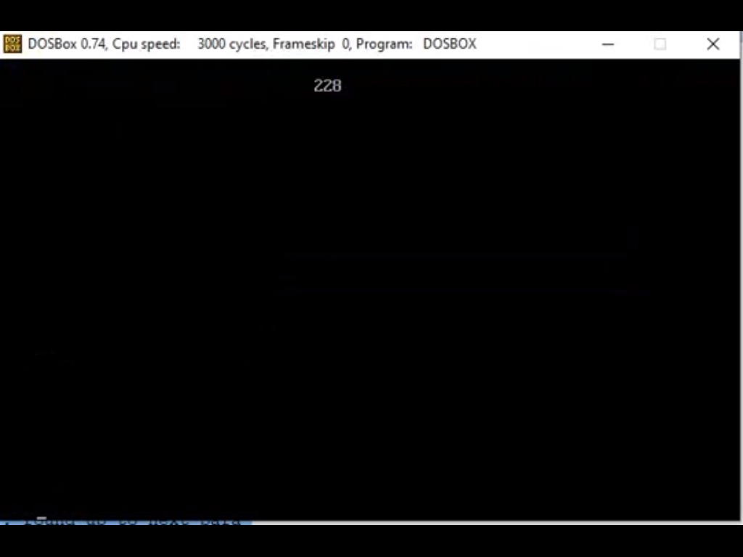

Activity 2

Assembly Language Code
[org 0x0100]
jmp start
tickcount: dw 0
randNum: dw 0
; subroutine to print a number at top left of screen
; takes the number to be printed as its parameter
clrscr: push es
push ax
push cx
push di
mov ax, 0xb800
mov es, ax ; point es to video base
xor di, di ; point di to top left column
mov ax, 0x0720 ; space char in normal attribute
mov cx, 2000 ; number of screen locations
cld ; auto increment mode
rep stosw ; clear the whole screen
pop di
pop cx
pop ax
pop es
ret

printnum: push bp
mov bp, sp
push es
push ax
push bx
push cx
push dx
push di
mov ax, 0xb800
mov es, ax ; point es to video base
mov ax, [bp+4] ; load number in ax
mov bx, 10 ; use base 10 for division
mov cx, 0 ; initialize count of digits

nextdigit: mov dx, 0 ; zero upper half of dividend
div bx ; divide by 10
add dl, 0x30 ; convert digit into ascii value
push dx ; save ascii value on stack
inc cx ; increment count of values
cmp ax, 0 ; is the quotient zero
jnz nextdigit ; if no divide it again

mov di, 0

nextpos:

mov al, 80 ; load al with columns per row
mul byte [randNum] ; multiply with y position
add ax, [randNum] ; add x position
shl ax, 1 ; turn into byte offset
mov di, ax ; point di to required location

pop dx ; remove a digit from the stack
mov dh, 0x07 ; use normal attribute
mov [es:di], dx ; print char on screen
add di, 2 ; move to next screen location
loop nextpos ; repeat for all digits on stack

loop nextpos

pop di
pop dx
pop cx
pop bx
pop ax
pop es
pop bp
ret 2

RANDOMPOS:
push bp
mov bp,sp
push cx
push ax
push dx

MOV AH, 00h ; interrupts to get system time
INT 1AH ; CX:DX now hold number of clock ticks since midnight
mov ax, dx
xor dx, dx
mov cx, 80;
div cx ; here dx contains the remainder of the division - from 0 to 9

add dl, '0' ; to ascii from '0' to '9'

mov word[randNum],dx;

pop cx;
pop ax;
pop dx;
pop bp;
ret

; timer interrupt service routine
timer: push ax
inc word [cs:tickcount]; increment tick count
push word [cs:tickcount]
call RANDOMPOS
call printnum ; print tick count
mov al, 0x20
out 0x20, al ; end of interrupt
pop ax
iret ; return from interrupt
start:
call clrscr

xor ax, ax
mov es, ax ; point es to IVT base
cli ; disable interrupts
mov word [es:8*4], timer; store offset at n*4
mov [es:8*4+2], cs ; store segment at n*4+2
sti ; enable interrupts
mov dx, start ; end of resident portion
add dx, 15 ; round up to next para
mov cl, 4
shr dx, cl ; number of paras
mov ax, 0x3100 ; terminate and stay resident
int 0x21
mov ax, 5 ; AX = 5
mov bx, 10 ; BX = 10
add ax, bx ; AX = AX + BX
mov bx, 15 ; BX = 15
add ax, bx ; AX = AX + BX
mov ax, 0x4c00 ;terminate the program
int 0x21

Debugging Screenshots

Activity 3

Assembly Language Code
; scroll down the screen
[org 0x0100]
jmp start
; subroutine to scrolls down the screen
; take the number of lines to scroll as parameter
scrolldown: push bp
mov bp,sp
push ax
push cx
push si
push di
push es
push ds

mov ax, 80 ; load chars per row in ax
mul byte [bp+4] ; calculate source position
push ax ; save position for later use
shl ax, 1 ; convert to byte offset
mov si, ax ; last location on the screen
mov cx, 2000 ; number of screen locations
sub cx, ax ; count of words to move
mov ax, 0xb800
mov es, ax ; point es to video base
mov ds, ax ; point ds to video base
mov di, 4000 ; point di to lower right column
std ; set auto decrement mode
rep movsw ; scroll up

pop ds
pop es
pop di
pop si
pop cx
pop ax
pop bp
ret 2

start: mov ax,7
push ax ; push number of lines to scroll
call scrolldown ; call scroll down subroutine

mov ax, 0x4c00 ; terminate program
int 0x21

Debugging Screenshots
